OCEANA COUNTY

**4-H SMALL MARKET**

**CHICKEN RECORD BOOK – 2023**

**(for ages 8 and up)**

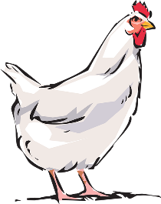

As a member of the Small Market Animal Project, you are required to submit your records as part of an educational project notebook in order to show your animal at the Oceana County Fair. **This notebook must be shown to the Poultry Superintendent or designated Small Market Weighmaster at the time of weigh-in and then entered by you in the Educational Notebook Division at the Oceana County Fair on Entry Day.**

**AGE: __________**

The age you enter depends on how old you were on January 1, 2023.

**NUMBER OF YEARS IN PROJECT: __________**

Use this sheet as the first page of your project record book. Fill it out completely.

**Please print or type neatly**.

# NAME ___________________________________________________________________

# 4-H CLUB ______________________________________________________________

**LEADER __________________________________________________________________**

# DATE RECORDS STARTED __________________ DATE ENDED _________________

**CHICKEN BREED VARIETY _________________________________________________**



**JUDGE’S SCORE/COMMENT SHEET**

**(PLEASE DO NOT REMOVE, PLACE THIS SHEET IN SHEET PROTECTOR OR GLUE TO COVER). This sheet must be keep free to the judge to write their comments.**

This sheet should help each 4-H’er understand their ribbon placing.

A. **Specific educational value or worth**

___ All questions were answered completely

___ All calculations were correct

___ Calculations were incorrect

___ Questions were not completely answered

___ Questions were not answered (missed questions)

B. **Notebook contains all project records**

___ Notebook contained all project records and were fully completed

___ Notebook contained additional project related information (research

materials etc.)

___ Project records were incomplete

___There was no additional project related information

C. **Accuracy, neatness and general appearance**

___Notebook was neat in appearance (typed/hand printed)

___ Notebook pages were clean and stain free

___Notebook pages were in order and complete

___Notebook pages were out of order and missing pages

___Notebook was difficult to read and messy

___Notebook had wrinkled and stained pages

Other Comments: __________________________________________________________________________________________

__________________________________________________________________________________________

__________________________________________________________________________________________

2023- SMA CHICKENS PAGE 2

## OBJECTIVES

1. Develop desirable work habits, sportsmanship, and ability to cooperate and express ideas through participation in projects, discussions, method demonstrations, judging teams, and exhibits.
2. Experience the pride and responsibility of leasing/owning and caring for poultry.
3. Learn how to feed, fit, show, breed and raise poultry.
4. Learn proper handling procedures to prevent injuries to 4-H members and their poultry projects.
5. Appreciate and use scientific information in poultry production and marketing.
6. Improve knowledge of grading, marketing and merchandising of poultry and poultry products.
7. Improve knowledge of the nutritive value of poultry meat and eggs and how they contribute toward good health.
8. Learn the importance of the poultry industry to the local, state, and national economies.
9. Acquire information on the opportunity that poultry offers as a career.

This record book is part of your Small Market Chicken project. By keeping records up-to-date you will be able to see how much progress you make as you set goals and work to accomplish them. Write or type neatly and clearly. Please keep the pages in order. Feel free to add extra pages at the end of your notebook.

SCORING CRITERIA

The following breakdown will be used during the judging process of all market livestock notebooks.

A. Specific educational value or worth **30%**

B. Creative way of showing what has been learned **10%**

C. Notebooks contains all project records **50%**

D. Accuracy, neatness and general appearance **10%**

The Oceana County 4-H Small Market Animal Committee encourages 4-H Leader and parent assistance with your project and project notebook. If you should have any questions, please contact the MSU Extension Office.

**If you needed extra help in filling out your notebook** please have whoever helped sign below that the answers are YOUR answers and that they assisted you in the writing of the answers and understanding of the questions only.

***(signature of person helping with writing if needed)***

2023- SMA CHICKENS PAGE 3

**JOURNAL OF CARE**

The SMAA Committee would like the judge to see the time and effort which you put into the care & management of your project.

Include the following:

* Feeding and watering practices
* Health practices and medicines (vaccinations, etc.)
* General Management (building a cage, cleaning living area, feed pans, etc.)

|  |
| --- |
| **DAILY- Things done once or twice a day** |
|  |
| **WEEKLY- Things done once or twice a week** |
|  |
| **MONTHLY- Things done once a month** |
|  |
| **YEARLY- Things done one time or occasionally throughout the year** |
|  |

2023- SMA CHICKENS PAGE 4

**Describe the type of chickens being used in this project. List breed and variety. Why did you choose this breed?**

______________________________________________________________________________

______________________________________________________________________________

______________________________________________________________________________

______________________________________________________________________________

______________________________________________________________________________

## WEIGHT CHART

|  |  |  |
| --- | --- | --- |
| Date | Age | **Weight** |
|  |  |  |
|  |  |  |
|  |  |  |
|  |  |  |
|  |  |  |
|  |  |  |

**\* FINAL WEIGHT (FW)___________ AGE__________ DATE___________**

***\* Final weight may need to be estimated depending on Covid 19 restrictions during summer of 2021.***

2023- SMA CHICKENS PAGE 5

## EXPENSES

##### (A) Cost of chicks $_______________________

|  |  |  |  |
| --- | --- | --- | --- |
| **DATE** | LBS. OF FEED | FEED VARIETY | COST |
|  |  |  | **$** |
|  |  |  |  |
|  |  |  |  |
|  |  |  |  |
| **(B)** |  | **TOTAL SPENT ON FEED** | **$** |

|  |  |  |
| --- | --- | --- |
| **DATE** | OTHER EXPENSES, VET, SUPPLIES, HOUSING, ETC. | COST |
|  |  | **$** |
|  |  |  |
|  |  |  |
|  |  |  |
| **(C)** | **TOTAL SPENT ON OTHER EXPENSES** | **$** |

##### GRAND TOTAL OF ALL EXPENSES (TE): $ _______________________

**(total of A+B+C)**

**_______________ ÷ _________________ = ______________________________________**

Total Expenses **(TE)** Final Weight **(FW)** Break Even Price **(BE)**

(total cost per pound to raise your animal)

**+ Final Weight may need to be estimated depending on Covid restrictions in summer of 2021.**

***\*\* The breakeven price is the price that you need to get at the***

***Small Market animal auction in order to not lose money on your market project \*\****

2023- SMA CHICKENS PAGE 6

**MARKETING**

One of the most important parts of any market animal project is marketing; this is how you get someone to come to the auction to buy your animal. It may include things such as writing letters and talking to possible buyers.

* What did you do to market your animal?
* If you had a market project in the past what did you do differently this year?

__________________________________________________________________________________

__________________________________________________________________________________

__________________________________________________________________________________

__________________________________________________________________________________

**PROJECT KNOWLEDGE**

**FEATHER COLORS & PATTERNS- draw a line from the name of the feather to the correct picture**

PENCILED

SPANGLED

MOTTLED

LACED

BARRED

STRIPED

2023- SMA CHICKENS PAGE 7

**READING A FEED LABEL**

**USING THE FEED TAG ON THE LEFT ANSWER THE FOLLOWING:**

1. Type of poultry: ___________________

2. Purpose: __________________________

___________________________________

3. Pounds: _______ Protein %: _______

4. Three major ingredients:

___________________________________

___________________________________

___________________________________

5. Is this feed medicated? ____________

6. The active drug ingredient is:

___________________________________

7. Withdrawal time for market poultry:

___________________________________

8. Name 2 Vitamin ingredients used:

___________________________________

___________________________________

2023- SMA CHICKENS PAGE 8

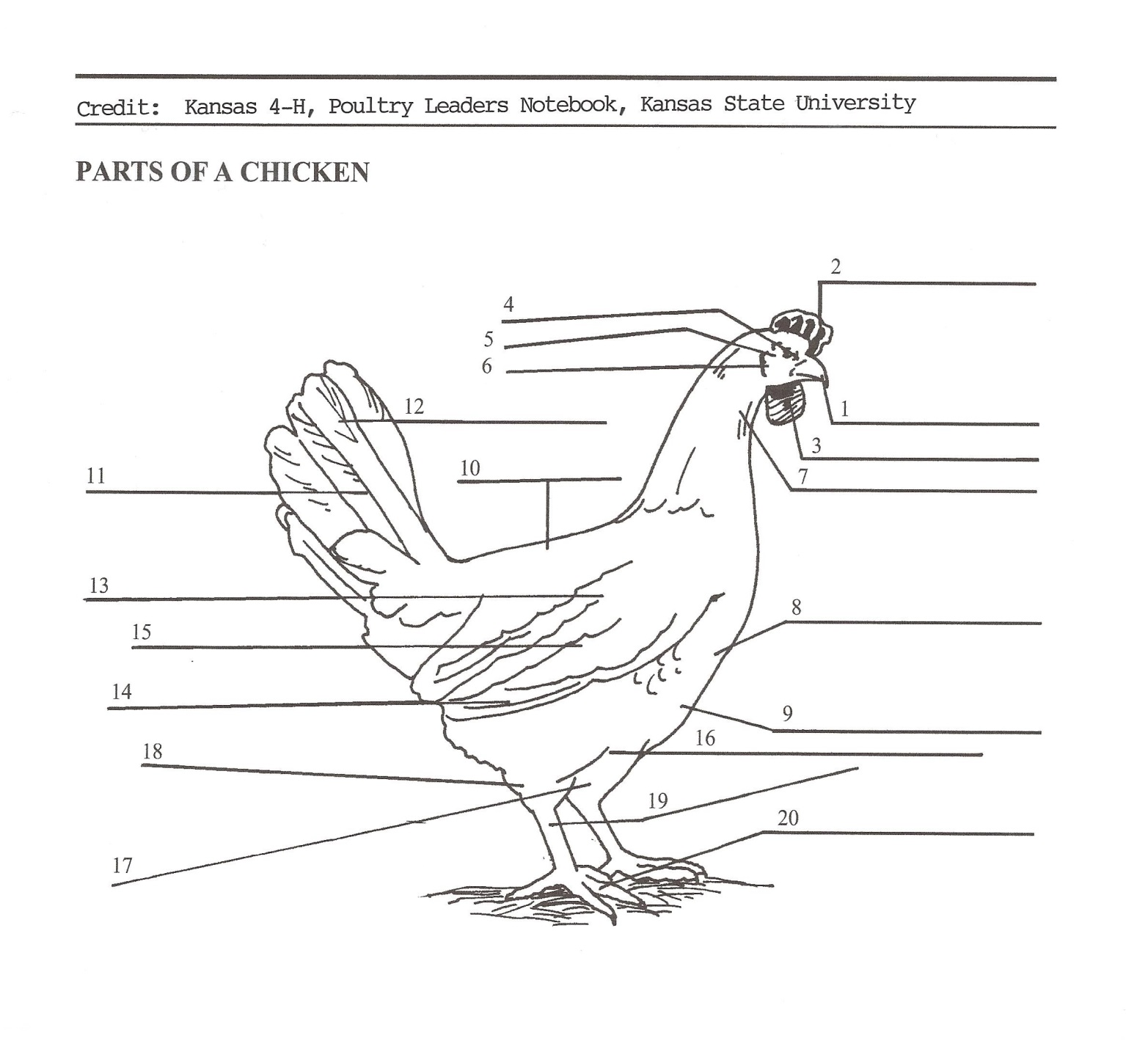

**WRITE THE CORRESPONDING NUMBER WITH THE PART BELOW**

_____ BACK (saddle or cushion) _____ EYES _____ TAIL

_____ BEAK _____ HACKLE FEATHERS (male) _____ TAIL FEATHERS

NECK FEAHTERS (female)

_____ BREAST _____ FLIGHT FEATHERS _____ THIGH

_____ COMB _____ HOCK JOINT _____ TOES

_____ COVERT FEATHERS _____ KEEL BONE _____ WATTLES

_____ EAR _____ LEG _____ WING

_____ EARLOBE _____ SHANK

2023- SMA CHICKENS PAGE 9

**POULTRY HEALTH-** answer the following questions to the best of your ability

1. What poultry diseases have your birds experienced? ____________________________

_______________________________________________________________________________

_______________________________________________________________________________

Why?__________________________________________________________________________

_______________________________________________________________________________

2. What are three types of parasites? ______________________________________________

_______________________________________________________________________________

3. What poultry parasites have you seen? __________________________________________

_______________________________________________________________________________

Where or when? _______________________________________________________________

______________________________________________________________________________

4. What are some common poultry health problems? ______________________________

_______________________________________________________________________________

_______________________________________________________________________________

_______________________________________________________________________________

5. What are three ways to prevent the most common poultry health problems?

_______________________________________________________________________________

_______________________________________________________________________________

_______________________________________________________________________________

_______________________________________________________________________________

2023- SMA CHICKENS PAGE 10

2023- SMA CHICKENS PAGE 11

**PROJECT KNOWLEDGE** (circle the correct answer to the question)

1. What is the document called that is used by the American Poultry Association to

describe purebred breeds of poultry?

A. Birds of a Feather B. American Standard of Perfection C. All About Poultry

2. A starter ration for market chickens should contain at least what percent of

protein?

A. 22% B. 50% C. 78%

3. A term used to describe a serious deformity or a defect which prevents a bird from

receiving an award.

A. Parasite B. Disqualification C. Molting

4. When removing a chicken from a cage, which end of the bird is brought out of

the cage first?

A. Head B. Back C. it does not matter

5. What is a female chicken less than 1 year of age called?

A. Pullet B. Hen C. Cockerel

6. What is a female chicken over one year of age called?

A. Pullet B. Hen C. Cockerel

7. What is a male chicken under one year of age?

A. Pullet B. Hen C. Cockerel

8. The horny formation projecting from the front of the head of chickens forming the

forward mouth-parts.

A. Bill B. Bean C. Beak

9. To be eligible to be shown in a 4-H Poultry Show, chicken and poultry exhibitors

must have a statement or origin or test negative for what disease- at the Oceana

County Fair they test for it upon entry day?

A. Pullorum Typhoid B. Coccidiosis C. Lice

2023- SMA CHICKENS PAGE 12

**PROJECT PROGRESS AND MANAGEMENT REPORT**

1. What part of your project did you enjoy the most? ___________________________

________________________________________________________________________

________________________________________________________________________

_______________________________________________________________________

2. What was the hardest part of your project? _______________________________________

________________________________________________________________________

________________________________________________________________________

________________________________________________________________________

3. Will you do the market poultry project again? ____________________

Why or why not? ________________________________________________________________

_______________________________________________________________________

________________________________________________________________________

4. Would you recommend the breed that you chose for a market project? _________

Why or why not? ______________________________________________________

_______________________________________________________________________

________________________________________________________________________

2023- SMA CHICKENS PAGE 13

**The 4-H Pledge**

(fill in the blanks)

***I Pledge:***

My HEAD to clearer _______________________________________,

My HEART to greater ______________________________________,

My HANDS to larger _______________________________________, and

My HEALTH to better ______________________________________,

For my ______________________________, my __________________________________,

My _________________________________, and my ______________________________.

The 4-H Mottos is: _________________________________________________________________.

**FIND, AND CIRCLE, THE FOLLOWING “4-H” WORDS IN THE PUZZLE BELOW**

***Do you practice these Actions?***

|  |  |  |  |  |  |  |  |  |  |  |  |  |
| --- | --- | --- | --- | --- | --- | --- | --- | --- | --- | --- | --- | --- |
| T | C | E | P | S | E | R | O | R | H | E | A | D  **WORD BANK:**  **CARING**  **CHARACTER**  **CITIZENSHIP**  **COMMUNITY**  **GIVING**  **HANDS**  **HEAD**  **HEALTH**  **HEART**  **HONESTY**  **INTEGRITY**  **RESPECT**  **SPORTSMANSHIP**  **TRUST** |
| G | O | B | L | U | E | W | C | A | E | N | G | E |
| P | W | I | N | T | H | E | I | G | A | M | E | O |
| I | C | H | A | R | A | C | T | E | R | S | V | Y |
| H | O | S | G | Z | N | A | I | A | T | I | L | T |
| S | M | P | O | I | D | E | Z | P | U | N | A | S |
| N | M | A | G | P | S | I | E | P | N | D | S | E |
| A | U | R | R | M | R | O | N | L | L | T | V | N |
| M | N | T | E | G | S | U | S | S | I | U | E | O |
| S | I | Y | E | N | T | Y | H | E | A | L | T | H |
| T | T | B | N | I | U | J | I | B | K | N | R | K |
| R | Y | A | B | V | W | K | P | A | E | E | U | F |
| O | L | S | A | I | X | L | S | N | T | L | S | E |
| P | M | K | L | G | N | I | R | A | C | I | T | P |
| S | Q | E | L | A | T | H | E | N | H | N | Y | T |
| G | H | T | W | Y | Z | O | R | A | E | G | I | R |
| I | N | T | E | G | R | I | T | Y | W | F | C | E |

2023- SMA CHICKENS PAGE 14

**MY 4-H STORY**

(Interesting things that happened to me and my animal this year, challenges, highlights of my year or anything else I would like to share about

my overall 4-H experience)

***POTENTIAL BUYERS NAMES***

As part of your 4-H Small Market Livestock Project, you must personally contact at least three potential buyers before the Oceana County Fair. You are encouraged to seek two new buyers that have not been asked or submitted before. **You also must have at least three different buyers than those of your siblings in the market livestock project.** Please confirm with your buyers their accurate mailing address (example: post office box vs. a street address). The information on page 15 must be completed and taken to the Oceana County MSU Extension Office on or before the due date where it will be **copied** and used to send out letters to your potential buyers. This page will remain in your notebooks. This is a Market Livestock Committee rule. Failure to comply will result in not being able to sell your animal in the 4-H Market Livestock Sale.

Page 15 Date:

2023 SMAA CHICKENS Staff: _______________

**SMALL MARKET/JUNIOR MARKET POTENTIAL BUYER’S LIST**

**CHICKEN PROJECT (AGES 8 & up)**

Name______________________________ Club_________________________

***Please print business names and complete addresses clearly.***

* 1. Contact Name ________________________________________________­­____

Business Name ____________________________________________________

**Mailing** Address _________________________City__­­­­­­­­__­­­­­­­_____________Zip_____

Phone _______________________ After Hours Phone______________________

Mailing Preference (Please Check One): Email ____ Postal Delivery ____

Email ____________________________________________________________

Signature__________________________________________________________

2. Contact Name ________________________________________________­­____

Business Name ____________________________________________________

**Mailing** Address _________________________City__­­­­­­­­__­­­­­­­_____________Zip_____

Phone _______________________ After Hours Phone______________________

Mailing Preference (Please Check One): Email ____ Postal Delivery ____

Email ____________________________________________________________

Signature__________________________________________________________

3. Contact Name ________________________________________________­­____

Business Name ____________________________________________________

**Mailing** Address _________________________City__­­­­­­­­__­­­­­­­_____________Zip_____

Phone _______________________ After Hours Phone______________________

Mailing Preference (Please Check One): Email ____ Postal Delivery ____

Email ____________________________________________________________

Signature__________________________________________________________

(Must be stamped by the MSU Extension Office)

2023- SMA MARKET CHICKENS PAGE 16

**PICTURES OF YOUR PROJECT**

(Please use this page for your project pictures. Add additional pages if you would like. The judges appreciate you labeling the pictures so they know what the picture shows.)

**CLUB POINTS**

**JUNIOR MARKET/SMALL ANIMAL ASSOCIATION PROJECT**

**ATTENDANCE RECORD**

|  |  |  |  |  |
| --- | --- | --- | --- | --- |
| **MEETING NAME** | **LOCATION** | **DATE** | **POINTS** | **SIGNATURE OF LEADER** |
|  |  |  |  |  |
|  |  |  |  |  |
|  |  |  |  |  |
|  |  |  |  |  |
|  |  |  |  |  |
|  |  |  |  |  |
|  |  |  |  |  |
|  |  |  |  |  |
|  |  |  |  |  |
|  |  |  |  |  |
|  |  |  |  |  |
|  |  |  |  |  |

**Please note:** This form must be included with your record notebook and turned into the weigh master on entry day of the Fair. You need to accumulate **nine (9)** points to be allowed to sell your animal. **Six (6)** of these nine (9) points must come from club meetings. **Three (3)** nonclub points must come from other types of meetings (example: clinics, shows, workshops, fair clean-up and/or county-wide awards).

# *NON-CLUB* POINTS

**JUNIOR MARKET/SMALL MARKET ANIMAL ASSOCATION PROJECT**

**ATTENDANCE RECORD**

***(this must be filled out when presenting for signatures at the office***

|  |  |  |  |  |
| --- | --- | --- | --- | --- |
| **MEETING NAME** | **LOCATION** | **DATE** | **POINTS** | **SIGNATURE OF LEADER, SUPERINTENDENT OR MSU STAFF** |
|  |  |  |  |  |
|  |  |  |  |  |
|  |  |  |  |  |
|  |  |  |  |  |
|  |  |  |  |  |
|  |  |  |  |  |
|  |  |  |  |  |
|  |  |  |  |  |
|  |  |  |  |  |
|  |  |  |  |  |

**Please note:** This form must be included with your record notebook and turned into the weigh master on entry day of the Fair. You need to accumulate **nine (9) points** to be allowed to sell your animal. **Six (6)** of these nine (9)pointsmust come from club meetings. **Three (3)** nonclub points must come from other types of meetings (example: clinics, shows, workshops, fair clean-up and/or county-wide awards).